DSA06 - Data Handling and Visualization
Activity 7 : Correlation Detective
R.No: 8 Reg. No: 192325043 Name: Bandaru Jahnavi

Case File CD-C08: The Coastal town Case
The code in the case file was run unchanged in R (set.seed(622170)), giving 14 daily records and 7 variables. All numbers below are output from that session.

Task 1. The matrix
n = 14 records (days) and 7 variables, so the number of distinct pairs of variables is 7 x 6 / 2 = 21.
round(cor(case), 2):
 | temp | icecream | rescues | pool_dev | complaints | lifeguards | sunscreen
temp | 1.00 | 0.97 | 0.92 | -0.07 | 0.20 | 0.00 | 0.25
icecream | 0.97 | 1.00 | 0.86 | -0.08 | 0.30 | 0.07 | 0.38
rescues | 0.92 | 0.86 | 1.00 | -0.01 | 0.13 | -0.10 | 0.25
pool_dev | -0.07 | -0.08 | -0.01 | 1.00 | 0.01 | 0.49 | 0.32
complaints | 0.20 | 0.30 | 0.13 | 0.01 | 1.00 | 0.07 | 0.45
lifeguards | 0.00 | 0.07 | -0.10 | 0.49 | 0.07 | 1.00 | 0.64
sunscreen | 0.25 | 0.38 | 0.25 | 0.32 | 0.45 | 0.64 | 1.00

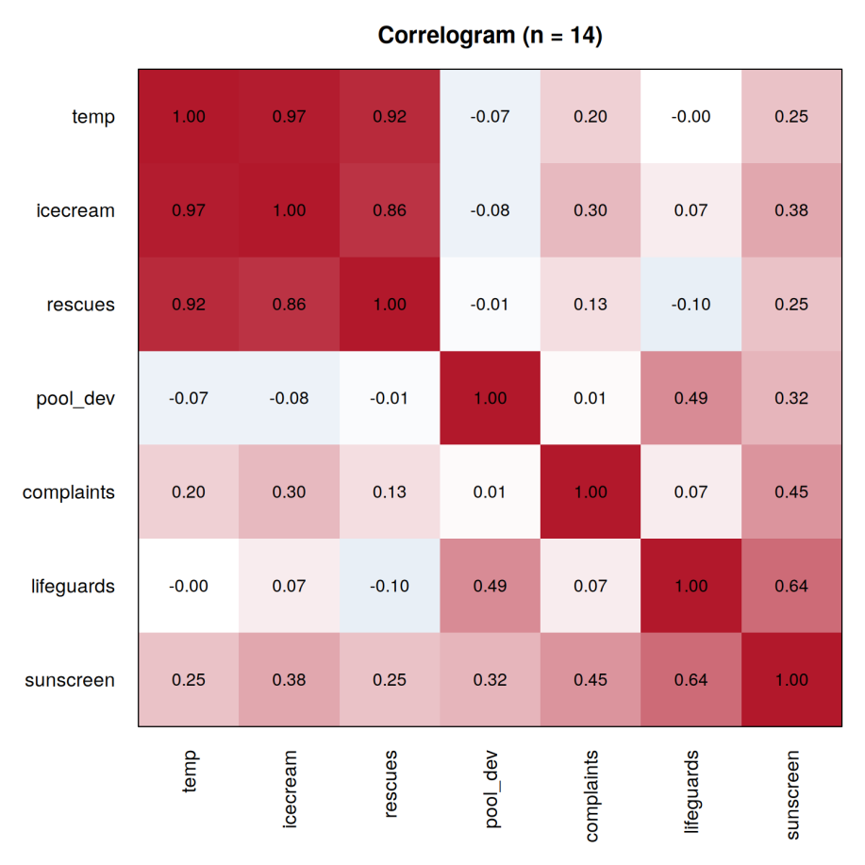

Task 2. The strongest clues
Clue | Pair | r | Strength
Strongest positive | temp and icecream | +0.97 (0.9652) | Strong (above 0.7)
Strongest negative | rescues and lifeguards | -0.10 (-0.0962) | Weak (below 0.3)

Next strongest positive pairs: temp and rescues 0.92, icecream and rescues 0.86, lifeguards and sunscreen 0.64. Every negative correlation in the matrix is tiny (-0.01 to -0.10), so there is no real negative linear relationship in this file.

Task 3. The deceptive zero
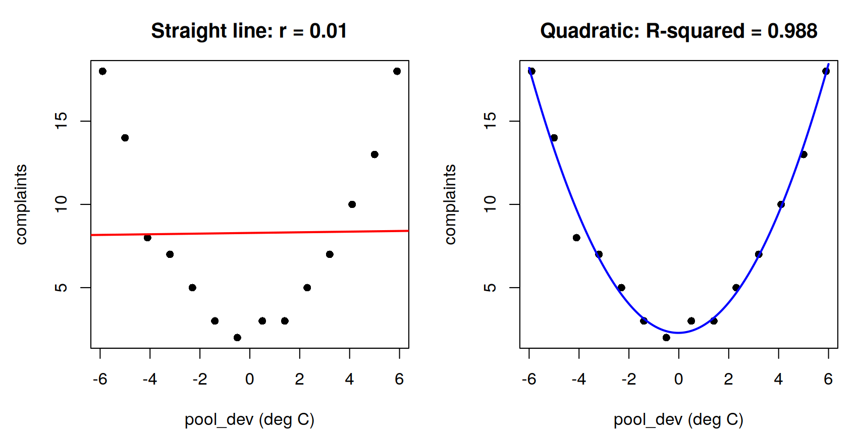

Quantity | Value
r (complaints, pool_dev) | 0.01 (0.0136)
R-squared of the straight line | 0.0002 (that is 0.0136 squared)
Quadratic fit | complaints = 2.28 + 0.020 x pool_dev + 0.445 x pool_dev squared
Quadratic R-squared | 0.988 (adjusted 0.986); the squared term has p = 5.5e-12

Why r misses it: r measures only straight-line association, and complaints rise on both sides of pool_dev = 0 (a U-shape) so the rising and falling arms cancel and r comes out near zero even though pool_dev explains 98.8% of the variation in complaints.

Task 4. The outlier alibi
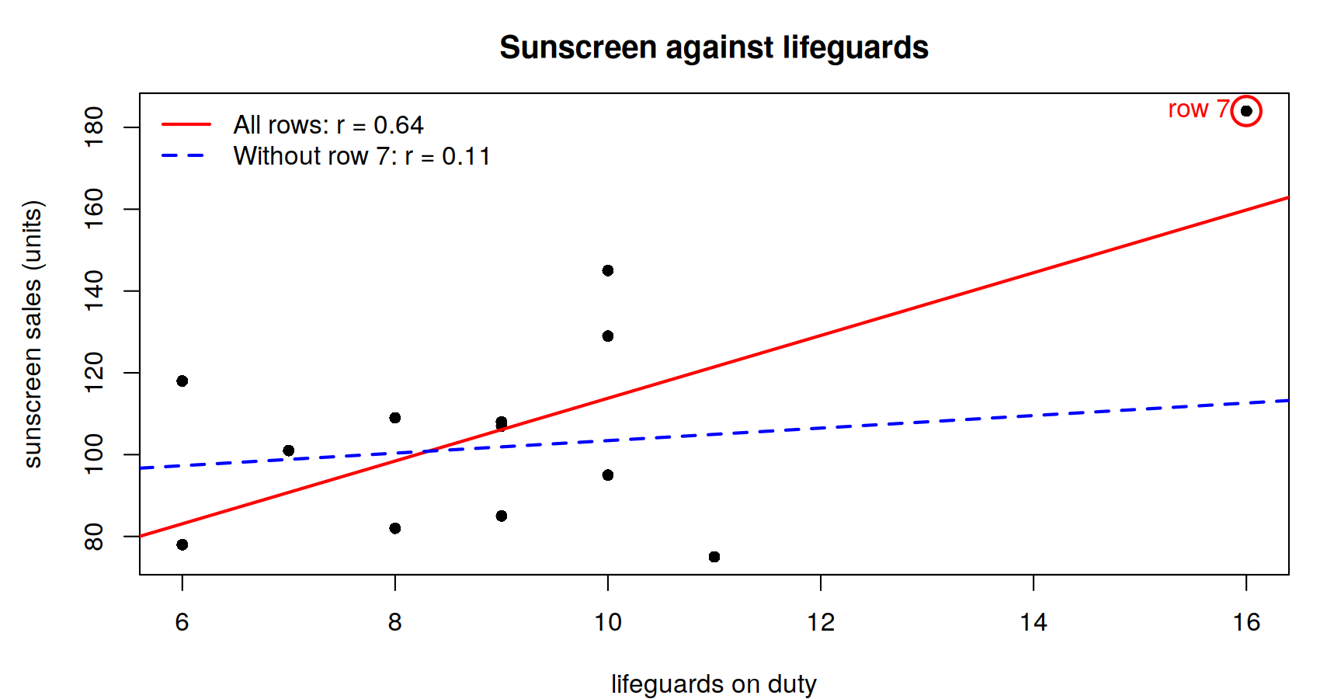

Correlation of lifeguards and sunscreen | r
All 14 rows | 0.64 (0.6354), moderate
Without row 7 (13 rows) | 0.11 (0.1138), weak

Effect of the single record: one point raised r from a weak 0.11 to a moderate 0.64 (more than five times as large), creating a relationship that is not in the other 13 days.

Task 5. The prime suspect
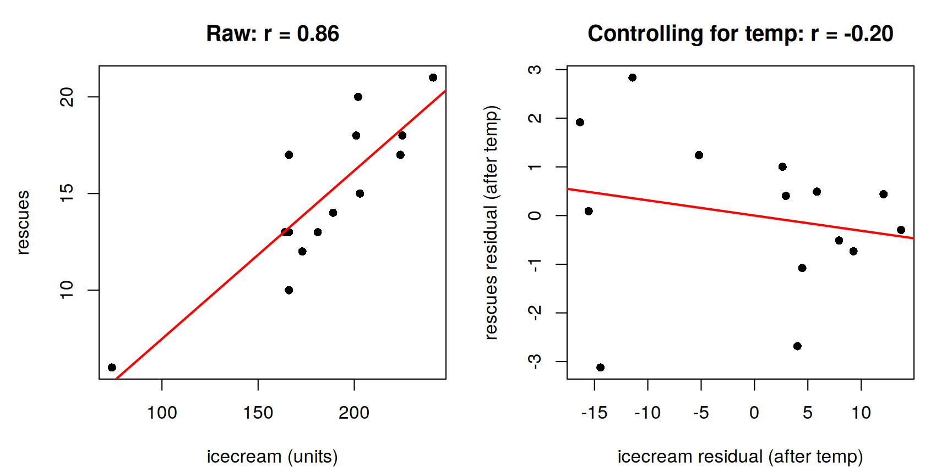

Correlation | r
icecream and rescues | 0.86 (0.8644)
temp and icecream | 0.97 (0.9652)
temp and rescues | 0.92 (0.9176)
Partial correlation of icecream and rescues controlling for temp: cor(resid(lm(icecream ~ temp)), resid(lm(rescues ~ temp))) | -0.20 (-0.2042)

Check with the formula: (0.8644 - 0.9652 x 0.9176) / sqrt((1 - 0.9652^2)(1 - 0.9176^2)) = -0.2042, the same value.
Verdict: No, icecream does not cause rescues: temperature is a hidden driver of both (r = 0.97 with icecream and 0.92 with rescues), and once temp is taken out the link drops from 0.86 (r squared 0.75) to -0.20 (r squared 0.04, p about 0.5, not distinguishable from zero with n = 14). Hot days bring more ice-cream buyers and more swimmers, so the two rise together without either causing the other.
Study design to test causation: a randomised controlled experiment, for example randomly assigning matched days of similar temperature (blocking on temp) to an ice-cream promotion or to no promotion, and comparing the rescue counts between the two sets of days.

Summary of the three traps
Trap | Evidence | Lesson
Hidden driver | icecream and rescues r = 0.86 falls to -0.20 after controlling for temp | Confounding: correlation does not prove cause
Curve that fools r | complaints and pool_dev r = 0.01 but quadratic R-squared = 0.988 | r detects only straight-line links; always plot
Single wrong record | lifeguards and sunscreen r = 0.64 falls to 0.11 without row 7 | One point can inflate r; check outliers

R code used
# (case file code exactly as given, then:)
cm <- round(cor(case), 2); cm; choose(7, 2)
# correlogram (ggplot2 version; not run here)
library(ggplot2); library(reshape2)
cl <- melt(cor(case))
ggplot(cl, aes(Var1, Var2, fill = value)) + geom_tile() +
geom_text(aes(label = sprintf("%.2f", value))) +
scale_fill_gradient2(low = "blue", mid = "white", high = "red", limits = c(-1, 1))
# Task 2
which(abs(cor(case)) == max(abs(cor(case)[upper.tri(cor(case))])), arr.ind = TRUE)
# Task 3
cor(case$complaints, case$pool_dev)
q <- lm(complaints ~ pool_dev + I(pool_dev^2), data = case); summary(q)$r.squared
ggplot(case, aes(pool_dev, complaints)) + geom_point() +
geom_smooth(method = "lm", se = FALSE) +
geom_smooth(method = "lm", formula = y ~ x + I(x^2), se = FALSE, colour = "red")
# Task 4
cor(case$lifeguards, case$sunscreen); cor(case$lifeguards[-7], case$sunscreen[-7])
# Task 5
cor(icecream, rescues); cor(temp, icecream); cor(temp, rescues)
cor(resid(lm(icecream ~ temp)), resid(lm(rescues ~ temp)))

